Some of us got names our parents just liked. Some of us are named after parents, grandparents, or family friends. And some of us are named after vampires, Disney princesses, witches, wizards, Kardashians, or the mermaid from *Splash…*even if we don’t know it. In fact, our parents might not even know it.

The US Social Security Administration has a database documenting popularity for every name given to more than five babies of a given gender in a given year from 1880 through 2017, letting me take a look at trends in the names of fictional and nonfictional pop-culture icons and their relationship to a name’s popularity. I looked at *a lot* of names—far more than are included here—and found a few key phenomena worth highlighting:

1. **Names and Gender**

Society is constantly grappling with redefining what we consider a “girl thing” or a “boy thing,” and the trends around baby names shine an interesting light on that. Sometimes as a name becomes more popular for girls, it becomes less popular for boys, and vice versa. Other times, a name’s increasing popularity for girls will actually make a name either more popular for boys or even coincide with its usage for boys for the first time.

1. **Alternate Spellings and Nicknames Vs. Full Names**

My middle name is Kaitlin. My mom chose that spelling; I know that for sure because my dad still doesn’t know what spelling I use. In his defense, figuring out the number of unique ways to spell Kaitlin/Caytlin/Katelyn could be a word problem in a middle school math class on permutations.

The advanced students can toss in whether they go by Kate or Cait or Katy or Catie—except that might mean their name is Katharine/Katherine/ Catherine/Kathryn—which might mean they go by Cat or Kathy (or Kat or Cathy).

Then you have names like Stephen/Steven and Ann/Anne where you’ve got a 50% chance at getting it right—33% if you’re counting whether they go by Steve or Annie.

The point is that spellings and nicknames evolve the same way words and expressions do—some people are doing something and then more people start doing it. We don’t often get to see how that plays out.

1. **Virality and Secondary Effects**

I will sometimes literally make a cup of tea when someone tells me they have a juicy story to tell me, because there’s something so satisfying in the dichotomy of sipping tea—the beverage of refinement and class, while delighting in someone else’s drama. When I think of the phrase “spilling the tea” or the Kermit “but that’s none of my business meme,” that’s what it reminds me of.

[However, the “T” originated in Black Drag Culture and originally was meant to symbolize the Truth, not the beverage.](https://www.merriam-webster.com/words-at-play/tea-slang-meaning-origin) The original phrase and denotation is still a part of many lexicons, but it has also sparked new expressions that are both clearly linked to these roots and blended with other expressions (like “spill it” or “spill the beans”).

Outside of the subculture where it originated, maybe you use “tea/T” or “shade” because you’ve been binge watching *RuPaul’s Drag Race*, you heard it from friends, you saw it online, or all of the above.

The point is that this sort of linguistic evolution happens all the time. They are the inside jokes and slang that sometimes never leave our closest circles, sometimes circulate in a subculture, and sometimes wind up everywhere. Names are an interesting microcosm of this sort of language evolution—the idea that things can go viral without the internet, that popularity can build on itself, and also how trends morph and spark one another.

1. **Cultural Capital**

Media and pop culture are so profoundly intertwined with our society and have so much meaning both in our own individual and broader cultural histories. Looking at their impact on naming trends is one small way to see the impact of individuals or works.

## Madison Ave

The movie *Splash* has the distinction of being the 10th highest grossing movie of 1984, the first movie with Tom Hanks that wasn’t a total flop, and popularizing the name Madison.

This is a pretty clear example of virality: In 1984, the main character from *Splash* christened herself “Madison” based on the famous east side Avenue, and by the end of the year, more girls were given the name Madison (42) than in the last 100 years combined (30). The rest is history.

Most people probably weren’t named after the movie, their parents just liked the name. I’m not the first one to note this—*Freakonomics* got there before me. Where this gets interesting is the adjacent trends. For example, the name Madeline also increased significantly in popularity through the ‘80s and ‘90s, whether because people wanted to call their daughters “Maddy” or because of the similar qualities between the two names. Either way, it’s a clear illustration that trends influence one another.

## Can you wiggle your nose?

The TV show *Bewitched* and its impact on the name Samantha is probably the next best known example of pop culture’s impact obscure baby name—a lot of baby name sites will mention it as part of the name Samantha’s origins. A closer look tells us a few things.

One way to get a better understanding of causal influence of show versus virality of a name is to look for more than one trend.

*Splash* introduced Madison onto the scene, but its cultural cache is not massive—names of other characters didn’t get a major bump and it’s not that frequently referenced today.

*Bewitched* has a lot more cultural capital, and one way to see that is the trends around Darren (Samantha’s husband), Tabitha (the couple’s daughter, introduced in 1966), Endora (Samantha’s mother).

The ongoing trends around the names Samantha and Tabitha probably have much more to do with the name’s virality than the show. However, the bursts of popularity across the board, and especially appearance of the unusual name Endora, tell us what this show meant to people in its heyday.

From a gender perspective, the TV show actually coincided with the use of the name Samantha for boys for the first time—which surprised me given the era, but at the same time the 60s was a decade in which we were pushing at gender boundaries quite a bit.

We also see a much larger trend in the popularity of the name Samuel (for boys, although it did trend upward slightly for girls). Like Madison and Madeline, the popularity of one name created a trend that extended to similar ones.

## The one where they named their kids

Among my favorite insights in this data is that the name Chandler had been trending upward for both genders from the mid-80s, and 1993 was the first time it was more popular for girls than boys. It feels very on brand for Ms. Shandellar Bong.

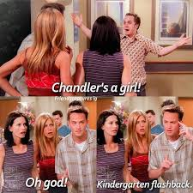

Among the more surprising findings is that while the name’s popularity skyrocketed for boys with the release of the show, the trend for girls actually reversed itself, and Chandler become more solidly a “boy’s name.”

If anything, I would have expected this trend to look like the one we saw for Samantha, and, had I expected that Samantha would be a boy’s name at all, I’d have guessed that trend would look more like this one.

Among the most profound results is that while Monica *may* have been subtly reversing after *Friends* began airing, but when the Lewinsky-Clinton Scandal began making headlines, the name’s usage went off a cliff. As the latest dramatization of the Clinton impeachment is slated to begin airing this month, this provides one tiny representation of both how much the incident permeated American society and how Monica Lewinski was perceived throughout.

## Once Upon a Time, There Were 3 Little Girls Who Went to the Police Academy

Overall, there are some pretty obvious trends here for the names of both the actresses, and the characters. At first glance, Jill (from Farrah Fawcett’s Jill Munroe) seems to be the only name that doesn’t show a response to the show’s release.

However, looking at the name Jillian makes a compelling case for the influence of the show and Fawcett’s character.

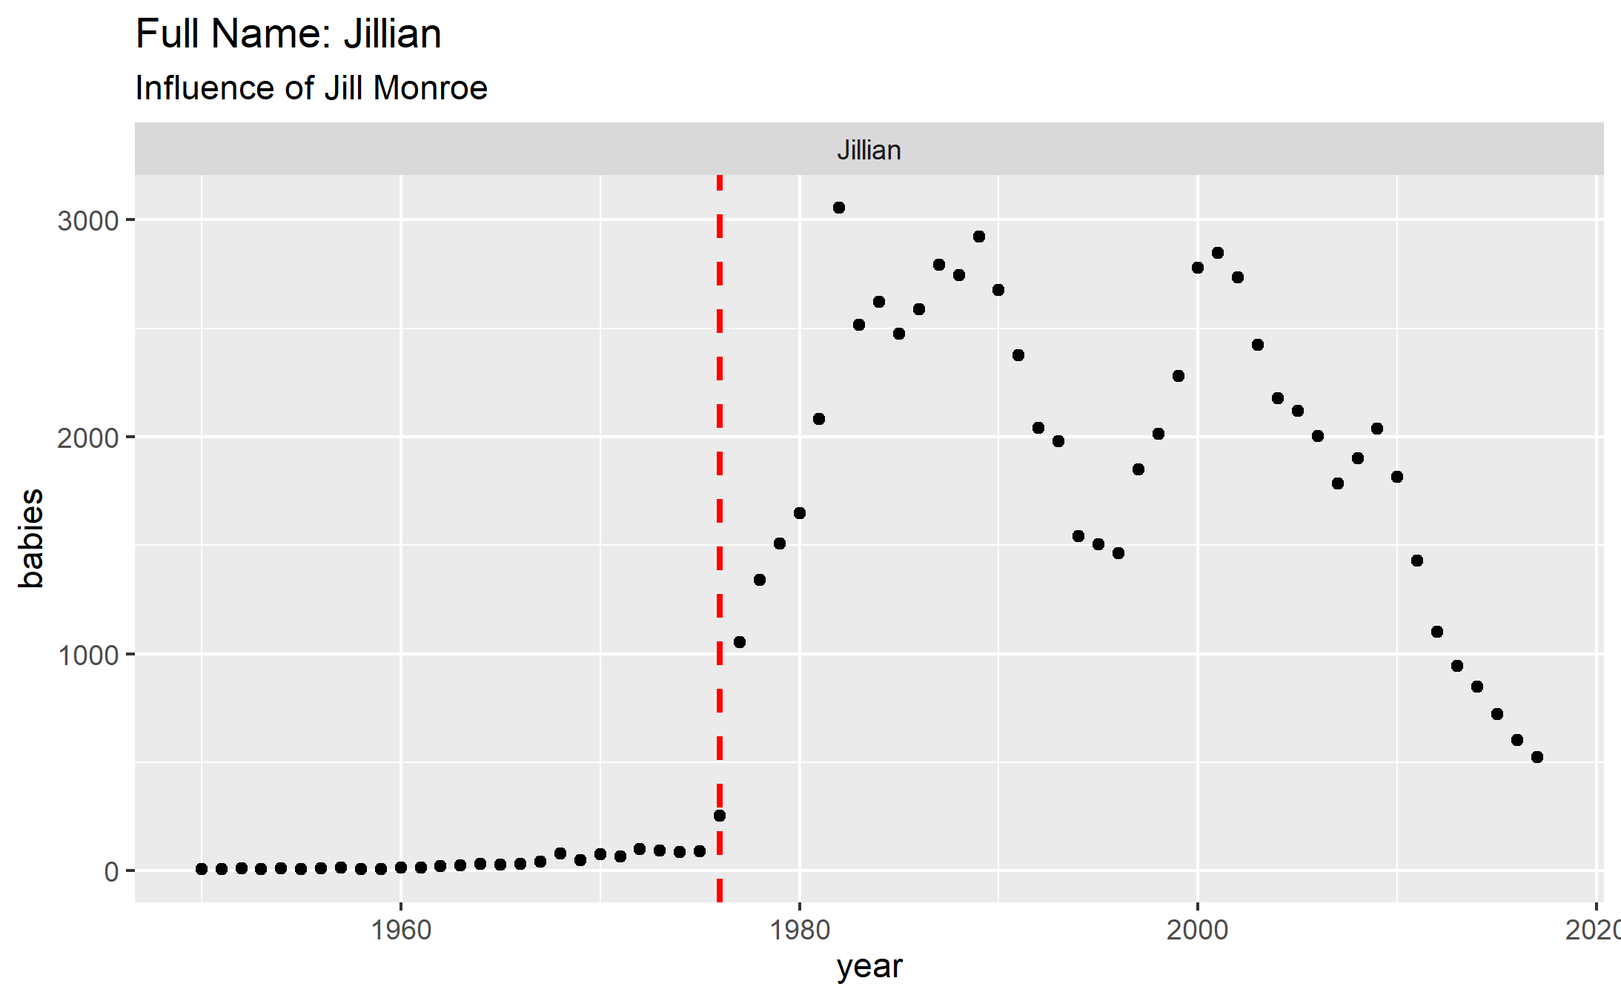

Looking at Kate Jackson and her character Sabrina Duncan tells a different story.

The name Kate was already trending up, but experienced a nice jump and an intensifying trend after the release of the show before beginning to decline in the mid-80s.

That trend obviously reverses again in the mid-90s, and the answer is likely Kate Winslet. In the same way that seeing a trend around the names of all three main characters and all three actresses portraying them makes for a pretty compelling argument for Charlie’s Angels’ influence on baby names (and, in turn, cultural relevance), we can double check our logic on Kate Winslet.

From 1997 to 1998, the usage of the name Rose for girls went from 666 to 1019 and usage of Leonardo for boys went from 707 to 1160. It’s not an airtight argument, to be sure, but it’s not a bad guess either.

As for Sabrina, the name had a big jump in ’76, and actually had its next big trend shift at the same time as Kate: the mid-90s. My best guess is that’s because of *Sabrina the Teenage Witch*, but I didn’t find any related trends (i.e. Melissa Joan Heart, Harvey), so it’s definitely harder to say.

You’re probably also wondering, if Jill made the name Jillian get more popular, did Kate make the name Katherine/Catherine get more popular? The answer: it’s really hard to tell. With a name as common as Katherine and with so many potential influences, isolating anyone would be a guess at best.

Looking at the influence of Jaclyn Smith is among the most interesting, because it shows one of the clearest examples of cause and effect thanks to the nontraditional spelling and nicknames. Not only does Smith popularize the nontraditional spelling of “Jaclyn” she reverses the declining trend on the spelling “Jacqueline”, which peaked, unsurprisingly, during Jackie Kennedy’s tenancy in the White House.

Also, unsurprisingly, while Jackie Kennedy had a much larger influence on the overall popularity of the name Jacqueline than Smith did, she had little to no impact on the “Jaclyn” spelling.

Moreover, while Kennedy clearly impacts the popularity of naming a child Jackie instead of Jacqueline, Smith has little to no impact on Jackie, underscoring both the individual impact of each of these two women, and how variations become grow and decline.

Overall, looking at a group of trends related to a single source gives as a window into so many different ways we can see the influence of pop culture.

## “You got people to name their children after you?” “What, like it’s hard?”

The name Reese was already trending up as a boys’ name in 1999 when the release of *Cruel Intentions,* starring Reese Witherspoon, started an upward trend in its popularity for girls, which was intensified after the release of *Legally Blonde*. In 2005, the name’s popularity for girls jumped again with the release of *Walk the Line.*

When, in 2003, Reese became a more popular name for girls than boys, it started trending downward as a boys’ name. A mirror of the effect we saw with Chandler, Reese becoming a “girl’s name” opens up a lot of interesting questions about gender.

In terms of cultural impact, again, we can get a better handle on this by looking at more than one trend. Reese Witherspoon’s influence can be illustrated through the characters she plays. While there wasn’t a really strong trend around Annette (*Cruel Intentions)*, but both Elle and June responded to their respective movie releases.

The films themselves also show an impact. The name Joaquin had been sharply increasing since Joaquin Phoenix’s appearance in *Gladiator*, but the name’s popularity jumped even further when Phoenix appeared in *Walk the Line.* As for characters, the names Sebastian (*Cruel Intentions*) and Johnny (*Walk the Line*) also responded to their respective movies.

Finally, in terms of adjacent trends, the name Ella, which has a much richer history than Elle (which first appears in 1977 and grows modestly alongside Elle McPherson’s popularity), jumped to a historic high within one year of *Legally Blonde’s* release.